Computing Fundamentals OEL 1
(FALL 2022)
Question No 1: From Given data find the overall average speed of all rides that satisfy the following criteria:
- The Type is wood
- The Design is Sit Down
- The Amusement Park has word “Park” in title
also compute the final results in the form of suitable visualization chart.
Solution:
Given data:
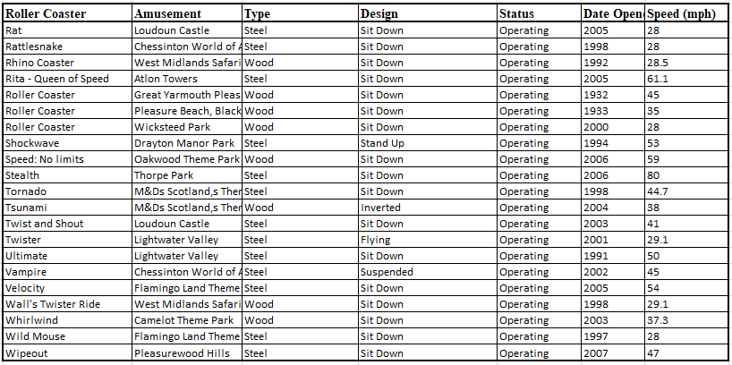
Result:
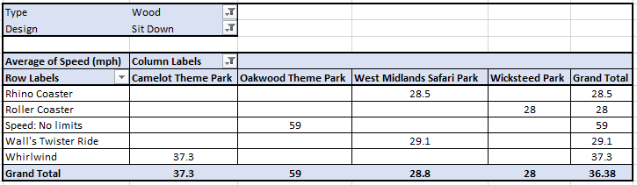
Question No 2: Create a student timetable and show it on a Web page.
Input:
<html>
<table border="4">
<tr>
<th colspan="6"><center>Time Table</center></th>
</tr>
<tr>
<th rowspan="7">Hours</th>
</tr>
<tr>
<th>Mon</th>
<th>Tue</th>
<th>Wed</th>
<th>Thu</th>
<th>Fri</th>
</tr>
<tr>
<td>Science</td>
<td>Maths</td>
<td>Science</td>
<td>Maths</td>
<td>Arts</td>
</tr>
<tr>
<td>Social</td>
<td>History</td>
<td>English</td>
<td>Social</td>
<td>Sports</td>
</tr>
<tr>
<th colspan="5"><center>Lunch</center></th>
</tr>
<tr>
<td>Science</td>
<td>Maths</td>
<td>Science</td>
<td>Maths</td>
<td rowspan="2">Preject</td>
</tr>
<tr>
<td>Social</td>
<td>History</td>
<td>English</td>
<td>Social</td>
</tr>
</table>
</html>

Output:
